Interview questions & answers

1. What is the basic structure of an HTML page?

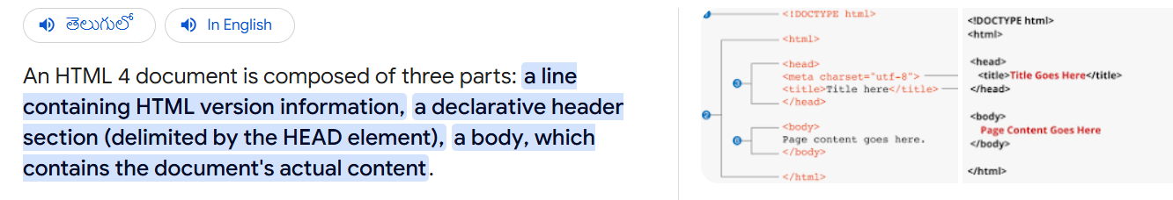

2.What are the predefined HTML tags you have experienced with?

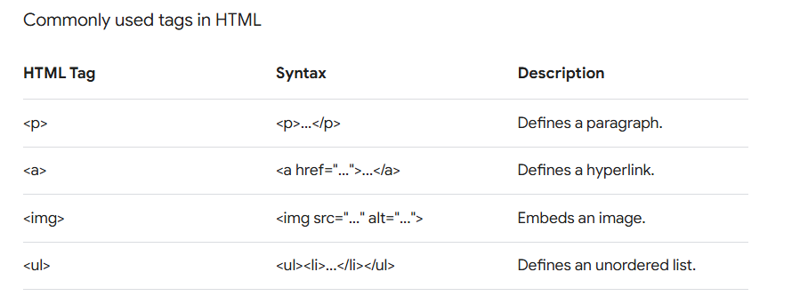

3.What are the predefined HTML tags?

